Title of the Paper

First Author and Second Author
Institution, City, State, Zip Code, Country

Abstract—The abstract should be between 100-200 words, and provide a stand-alone summary of the paper. Do not just replicate the introduction and conclusion sections.
Index Terms—About four to six key words or phrases in alphabetical order, separated by commas.

- Introduction
This is the introduction of the paper.
- Body of Paper
- Formatting
Please follow the formatting of this template.
- Citations
Citations should be given in author-year format. For one author, list the author’s last name and the year of the publication (Rhudy, 2013). For two authors, list both authors’ last names and the year (Rhudy and Gu, 2013). For more than two authors, list the first author’s last name followed by “et al.” (Rhudy et al., 2013). Cited references should then be provided in the references section in alphabetical order. To cite multiple papers at the same time, separate each citation with a semi-colon (Rhudy et al., 2013; Smith and Doe, 1999). For multiple papers that have the same author and year, denote each with lowercase letters starting with ‘a’ (Rhudy et al., 2013a; Rhudy et al., 2013b). These letters should also be noted in the references section.
- Equations
Number equations consecutively with equation numbers in parentheses flush with the right margin. The equations should be centered on the page.
- Figures
Number figures consecutively with the label ‘Figure’ in the caption below the figure. Figures and captions should be centered on the page, e.g. see Figure 1, or can be embedded in the text.
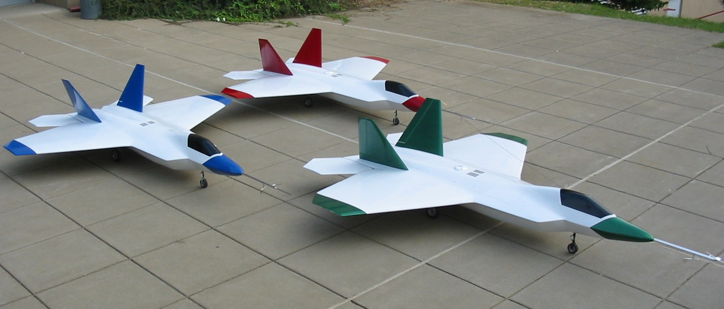
Figure 1. Example Figure

- Tables
Number tables consecutively with the label ‘Table’ in the caption above the table. Tables and captions should be centered on the page, e.g. see Table 1. Use double horizontal lines above and below the table, and a single horizontal line below the first row of the table. Do not use vertical rules.
Table 1. Example Table
Number | Type | Class
1 | Aircraft | A
2 | Automobile | B
3 | Robot | C

- Conclusions
Conclusions of the article.
Acknowledgement
This section is optional.
References
List references here in alphabetical order. Use IEEE formatting for all citations. See example citations below.
Gross, J., Gu, Y., Rhudy, M., Gururajan, S., and Napolitano, M., “Flight Test Evaluation of GPS/INS Sensor Fusion Algorithms for Attitude Estimation,” IEEE Trans. on Aerospace Electronic Systems, Vol. 48, No. 3, July 2012, pp. 2128-2139.
Rhudy, M., Gu, Y., Gross, J., and Napolitano, M. R., “Sensitivity Analysis of EKF and UKF in GPS/INS Sensor Fusion,” AIAA Guidance, Navigation and Control Conference, Portland, 2011.
Document History
Initial Manuscript Submission: May XX, 2013
Initial Review Completed (V1.0 Upload): May XX, 2013
Minor Revision Performed (V1.1 Upload): May XX, 2013
List of changes:
Major Revision Performed (V2.0 Upload): May XX, 2013
List of changes:

First Author Title, Affiliation, and Contact Information.
Second Author Title, Affiliation, and Contact Information. Citation: First Author and Second Author, “Title of Paper,” Interactive Robotics Letters, West Virginia University, April 2013. Link: http://www2.statler.wvu.edu/~irl/index_files/OnlineJournal.htm Copyright: © 2013 First Author and Second Author. This is an open-access article distributed under the terms of the Creative Commons Attribution License, which permits unrestricted use, distribution, and reproduction in any medium, provided the original author and source are credited.

